**SOCIALIST REPUBLIC OF VIETNAM**

**Independence - Freedom - Happiness**

**IDENTIFY CARD**

**No.: 012345678**

Full name:  **NGUYEN VAN A**

Date of birth: November 22nd, 1990

Native place: Ho Chi Minh City

Place of permanent: No. 50, Street 17, Ward 4, District 4, Ho Chi Minh City

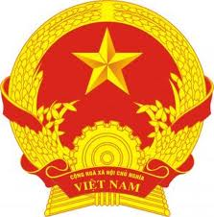

Photo

|  |  |  |
| --- | --- | --- |
| Ethnic Group: **Kinh** Religion: **Catholicism** | | |
|  | LEFT FOREFINGER | INDIVIDUAL TRACES AND DEFORMITIES |
| Mole 0.5cm under the left side of the nose |
| Dated July 11th, 2015  DIRECTOR OF HO CHI MINH’S PUBLIC SECURITY  *(Signed and sealed)*  *Nguyen Chi Dung* |
|  | RIGHT FOREFINGER |